

**Smart Dustbin (IOT)**

***DOCUMENTATION***

**Date: 16-08-2023**

This project is done by

**Student id: 1283389 SHOUL NADEEM**

**Student id: 1278380 RABIA NOOR**

**Student id: 1239205 AMMARAH JAMIL Student id: 1278382 SABA NOOR**

**Student id: 128554 JAVERIA RAHIM**

**PROJECT INSTRUCTOR:**

**Sir Jawad Ahmed**

**This is to certify that the project report entitled**

**“Smart Dustbin” is Submitted by SHOUL NADEEM , RABIA , AMMARAH , JAVERIA,**

**SABA has successfully designed and developed [IOT Project] .**

**This project is a bonafide record of the work carries out under our guidance and supervision**

**at APTECH SFC**

**Date of Issue: 12-July-2023**

**PROJECT CERTIFICATION**

**Table of Contents**

**1**. Introduction

**2**. Features

**3**. Installation and Setup

**4**. Usage

**5**. Maintenance

**6**. Troubleshooting

**7**. Frequently Asked Questions FAQs)

**8**. Technical Specifications

**9**. Warranty and Support

**10**. Conclusion

**1. Introduction**

The Smart Dustbin is an innovative and technologically advanced waste management solution designed to streamline waste disposal processes, enhance cleanliness, and contribute to a more sustainable environment. This documentation provides comprehensive information on the features, installation, usage, maintenance, troubleshooting, and technical specifications of the Smart Dustbin.

**2. Features**

Automatic Opening: The Smart Dustbin employs motion sensors to detect when a person approaches it, triggering the lid to automatically open without the need for physical contact.

Energy Efficiency: The system incorporates energy-efficient components, including low-power sensors and a rechargeable battery.

Easy Maintenance: Designed for effortless cleaning and maintenance, with removable components.

Sleek Design: The modern and sleek design of the Smart Dustbin complements various environments, including homes, offices, public spaces, and more.

**3. Installation and Setup**

1. Choose a suitable location for the dustbin, ensuring it has easy access for waste disposal and maintenance.

3. Download and install the dedicated smartphone app from the App Store or Google Play Store.

4. Follow the app's instructions to connect the dustbin.

**4. Usage**

1. Approach the dustbin, and the motion sensor will automatically open.

2. Deposit the waste into the bin.

**5. Maintenance**

1. Regularly empty and clean the dustbin compartments to prevent overflow and maintain hygiene.

2. Clean the exterior of the dustbin using a damp cloth.

**7. Frequently Asked Questions (FAQs**)

Q1: Can I use regular trash bags with the Smart Dustbin?

A1: Yes, the dustbin is designed to accommodate standard trash bags.

Q2: Is the dustbin suitable for outdoor use?

A2: The dustbin is primarily designed for indoor use, but it can be placed in covered outdoor areas.

**8. Circuit**

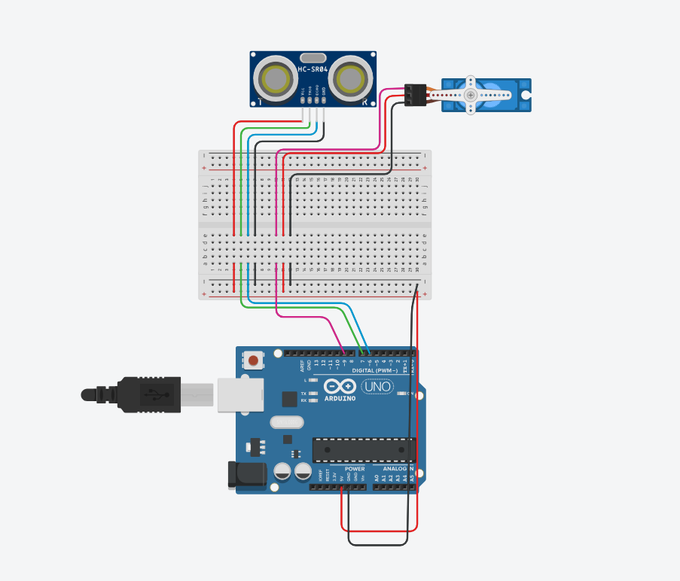

**9. Code**

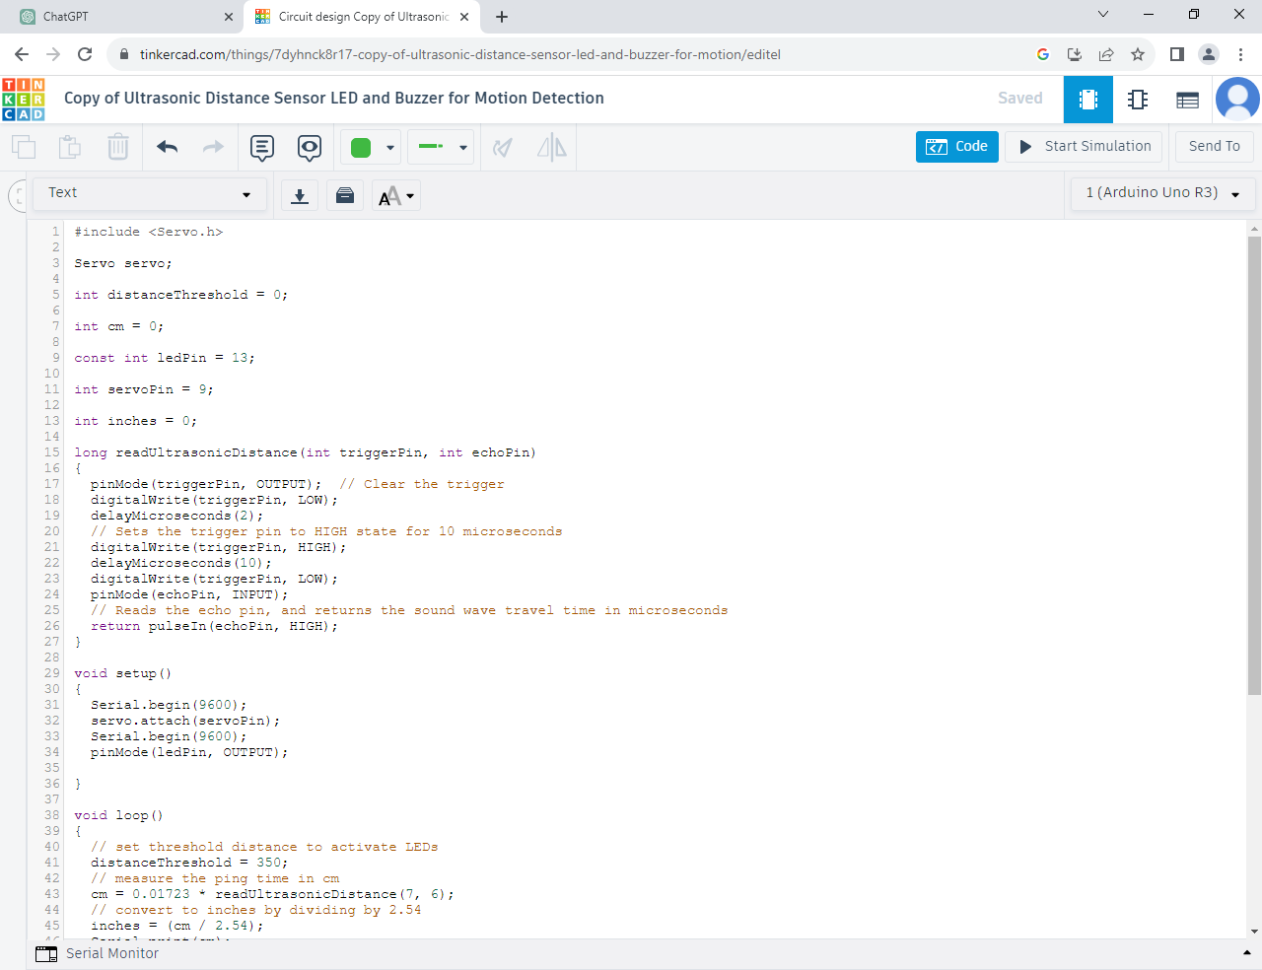

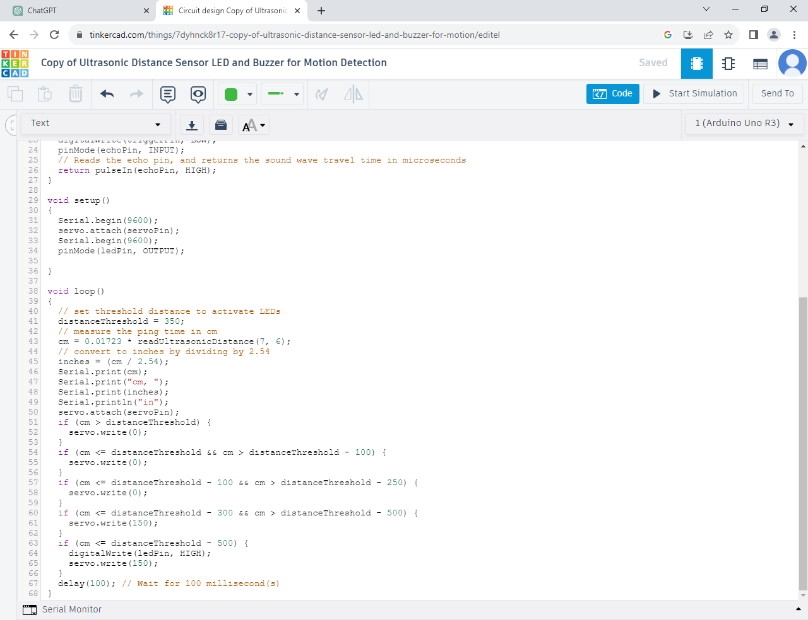

**10. Conclusion**

The Smart Dustbin offers a convenient and efficient waste management solution that incorporates cutting-edge technology to enhance cleanliness, reduce odors, and promote sustainable waste disposal practices. With its smart features and user-friendly design, the Smart Dustbin is an essential addition to modern homes, offices, and public spaces.

**11. Component Used**

**.** Ultrasonic Distance Sensor

An ultrasonic sensor is an instrument that measures the distance to an object using ultrasonic sound waves. An ultrasonic sensor uses a transducer to send and receive ultrasonic pulses that relay back information about an object's proximity

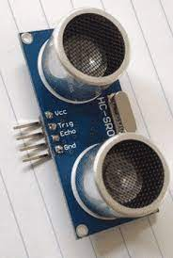

**.** Micro Servo

A Servo motor is a type of motor that is powered by a DC source, either from an external supply or by a controller. A small and lightweight servo motor with high output power is called a micro servo motor

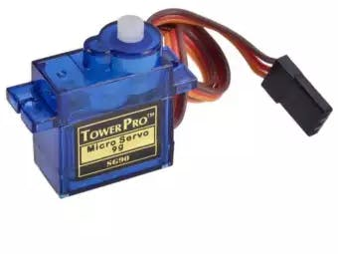

**.** Breadboard Smart

A breadboard, solderless breadboard, or protoboard is a construction base used to build semi-permanent prototypes of electronic circuits. Unlike a perfboard or stripboard, breadboards do not require soldering or destruction of tracks and are hence reusable.

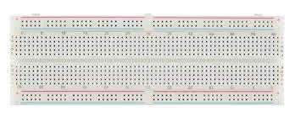

**.** Arduino

Arduino UNO is a low-cost, flexible, and easy-to-use programmable open-source microcontroller board that can be integrated into a variety of electronic projects.

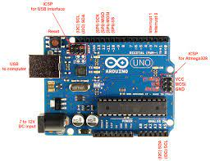

**.** Jumper wire

Jumper wires are electrical wires with connector pins at each end. They are used to connect two points in a circuit without soldering. You can use jumper wires to modify a circuit or diagnose problems in a circuit.

